King of the Rip 2017

The 5th round of the ANSA Victoria State Championship was run over the April 1st 2nd weekend. The weather was OK on Friday night and Saturday was terrible with very strong winds making fishing tough , however Sunday was a good day. We had some good captures with Gummy Shark to 5.5Kg and Snapper to 5.9kg. We had 64 anglers from eight clubs compete and all had a good time.

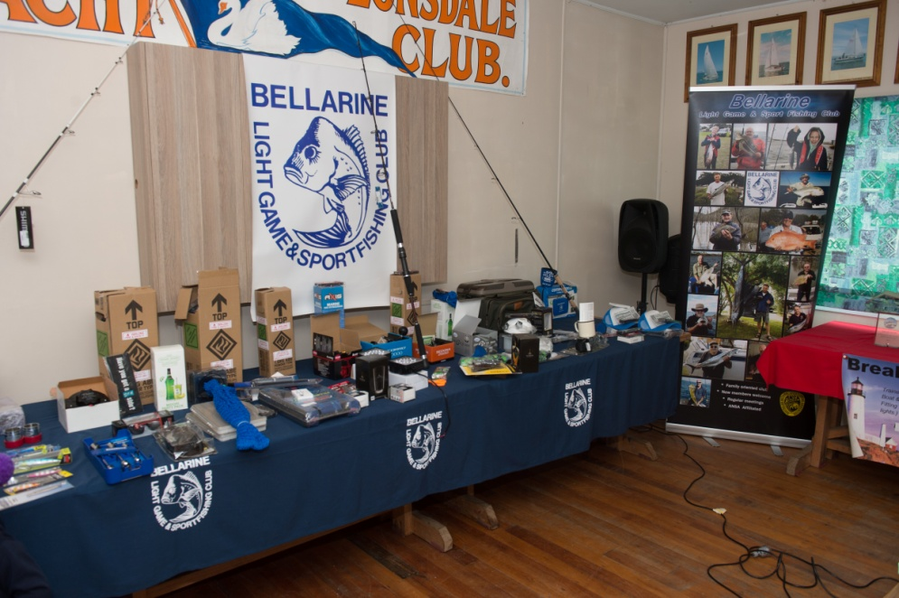

As we all know coming into this competition we had three clubs on very close for the State Champion ship so completion was fierce but friendly. The results were:
The highest point scoring senior Victorian team – 1st -Southern Boat Fishing Club - team 1 – 839.07 pts
Frank Aarsman, Frank Naylor, Keith Chapman, Celeste Chapman
2nd – Bellarine LG & SFC – team 2 – 775.14 pts
3rd – Drysdale SFC – team 2 – 676.48 pts

The highest point scoring junior Victorian team – 1st – Bellarine LG & SFC – team 1 – 435.59 pts
Emily Whitford, Ellie Gibson, Tyler Sparks, Luke Robinson
2nd – DrysdSouthern Boat FC– team 1 – 119.48 pts
3Rd – Drysdale SFC – team 1 – 95.52 pts

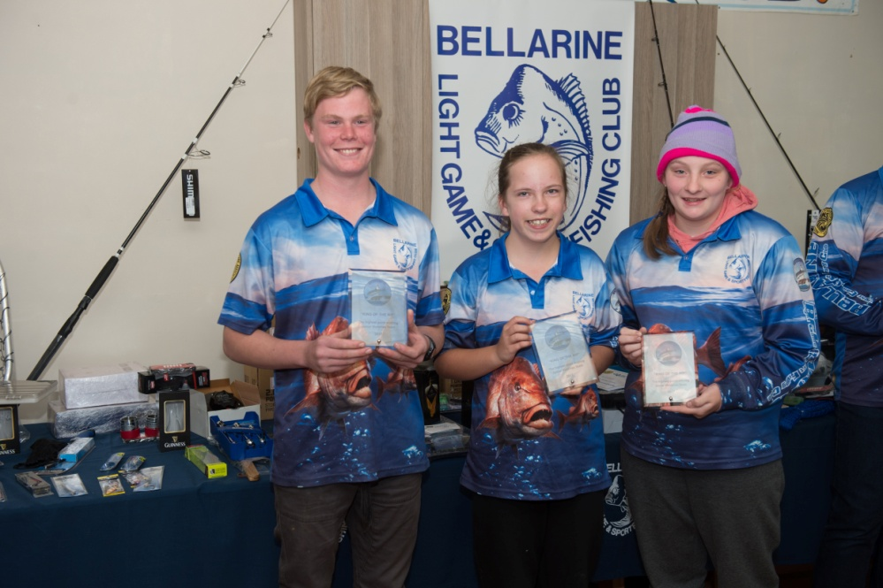

The highest aggregate - Senior Male – Daniel Sparks (Bellarine LG & SFC) – 534.3 pts

The highest aggregate - Senior Female – Celeste Chapman (Southern Boat FC) – 386.12 pts

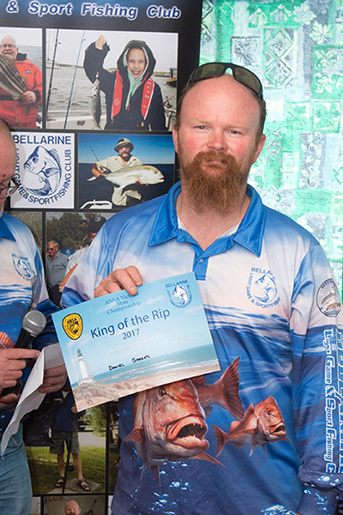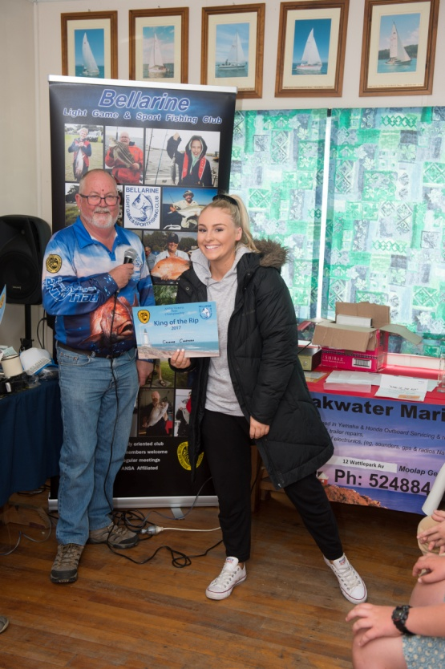

The highest aggregate - Junior Male – Luke Robinson (Bellarine LG & FSC) – 241.4 pts

The highest aggregate - Junior Female – Ellie Gibson (Bellarine LG & FSC) – 133.69 pts

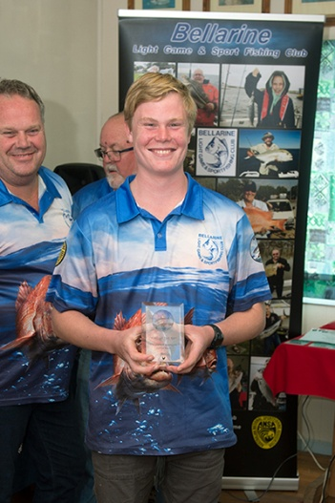

The highest aggregate - Sub Junior Male – Anthony Di santo (Southern Boat FC) – 54.25 pts

The highest aggregate - Sub Junior Female – Tresea Di Santo (Southern Boat FC)– 65.27 pts

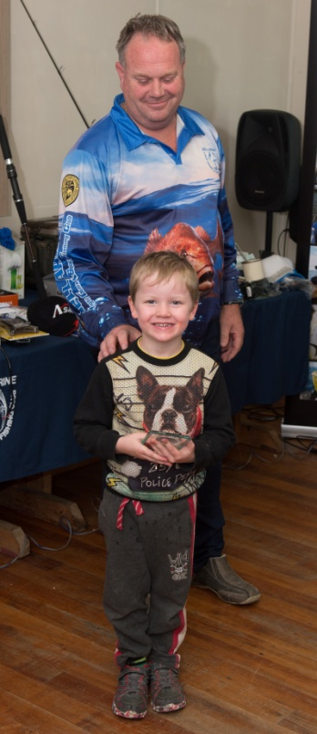
These kids are our future and we should encourage them as much as possible.

The highest point scoring fish – Estuary – Jarrod Biles – Williamstown SFC – Bream 0.669 kg

The highest point scoring fish – Landbased Award – Jarrod Biles – Williamstown SFC – Bream 0.669 kg

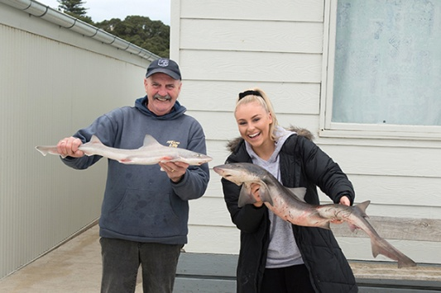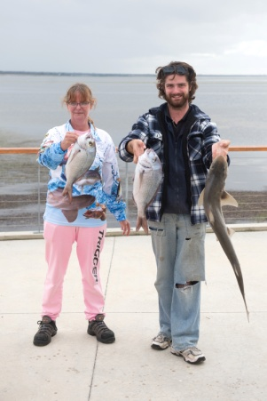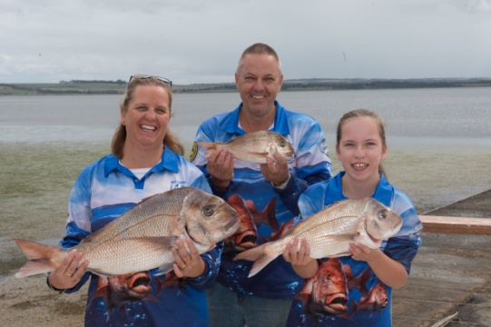

So to all those that competed, congratulation on the effort you all put in. And hope that we get good support for the Otway convention 29th 30th April.

Finally to our sponsors that supported us for this convention as the sponsorship this year was one of the best ever. Hope that your support can continue in 2018.

